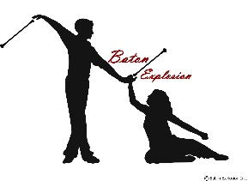
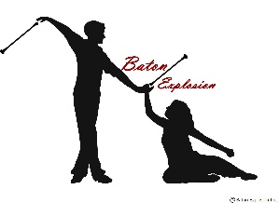
FALL SESSION – COMPETITIVE

BATON TWIRLING CLASSES
FOREST HILLS SCHOOL

DAY | DATE | TIME (S)
FRIDAY | 9/10/2021 | 6:30 – 8:30
 | 9/17/2021
 | 9/24/2021
* | 10/1/2021
* | 10/8/2021
* | 10/15/2021
* | 10/22/2021
* | 10/29/2021
* | 11/8/2021
* | 11/12/2021
* | 11/26/2021
* | 12/10/2021
Baton |  | $48
Baton NB Yearly Membership |  | $45
*Discount/2nd Same | Family Member | $20

