KidSport™ Chapters

Restigouche Chapter:
Denise Duchesne denise.duchesne@gnb.ca
113 Roseberry Street, Campbellton, NB E3N 2G6
Phone : 789.2387 Fax:789.2999

Chaleur Chapter:
Ryan Wilbur Ryan.Wilbur@bathurst.ca
850 St. Anne Bathurst, N.B., E2A 6X2
Phone 548.0410 Fax 548-0406

Acadian Peninsula Chapter:
Hillary Pineau programs@sportnb.com
900 Hanwell Rd. Suite 13, Fredericton, N.B.
E3B 6A2 Phone: 451-1320 Fax: 451-1325

Miramichi Chapter:
Holly Allison Holly.Allison@miramichi.org
94 General Manson Way Unit 4 Miramichi, NB
E1N 6K8 Phone: 506-623.2314 Fax: 623.2306

Kent County Chapter:
Nick Boudreau Nick.Boudreau@gnb.ca
178 Water Street, Miramichi NB E1N 1B6
Phone: 625-1316

St. Stephen Chapter :
Susan MacDonald
Susan.macdonald2@nbed.nb.ca
32 Union Street St. Stephen , N.B. E3L 1T4
Fax: 466.7336

Moncton/Saint John/Sussex/Fredericton and all other regions:
Hillary Pineau programs@sportnb.com
900 Hanwell Rd, Suite 13Fredericton, NB E3B 6A2 Phone: 451.1320 Fax: 451.1325

Guidelines for Grants

• Preference is given to children who are
being introduced into organized sport.

• Grants will not exceed a maximum of
$200 per calendar year.

• Grants to individual children are designed
to address the financial obstacles that
prevent children from participating in
sport

• Grants may be used only for the payment of
participant fees and/or mandatory personal
sport equipment.

• Sport activities must be recognized by the
member organizations of Sport New
Brunswick.

• Children 18 years old and under are eligible.

• Travel to play-offs, championships,
camps and equipment upgrades etc. are
not an eligible expense.

• KidSport™ grants are not meant to
replace existing recreation or social
services funding for sport participation.

• The KidSport™ Fund will issue funds to
a recognized sport organization on
behalf of the child recipient or arrange
for the purchase of equipment.

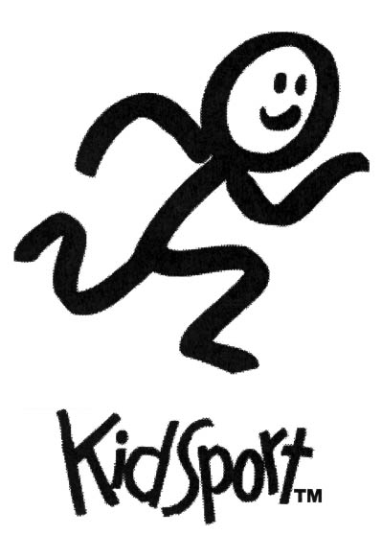

Application Form
“The Maritime NHL’ers for KIDS Society is a local maritime charity established to help children participate in minor hockey throughout the Maritimes. The Maritime NHL’ers, in partnership with the NHL Player’s Association, also provides funding and equipment grants to further assist NB children participate in minor hockey.”
“The Maritime NHL’ers for KIDS Society is a local maritime charity established to help children participate in minor hockey throughout the Maritimes. The Maritime NHL’ers, in partnership with the NHL Player’s Association, also provides funding and equipment grants to further assist NB children participate in minor hockey.”
“The Maritime NHL’ers for KIDS Society is a local maritime charity established to help children participate in minor hockey throughout the Maritimes. The Maritime NHL’ers, in partnership with the NHL Player’s Association, also provides funding and equipment grants to further assist NB children participate in minor hockey.”
“The Maritime NHL’ers for KIDS Society is a local maritime charity established to help children participate in minor hockey throughout the Maritimes. The Maritime NHL’ers, in partnership with the NHL Player’s Association, also provides funding and equipment grants to further assist NB children participate in minor hockey.”

Deadlines:
January 31, May 1, and September 1

www.KidSport.ca
ALL INFORMATION MUST BE COMPLETED- Confidentiality of all applicants will be protected.
Section 1: Child Information – Please Print
First Name: |  | Last Name:
Address:
City: |  | Postal Code:
Telephone: (506) |  | Gender: Male ____ Female ____
Date of Birth: |  | Sport funding will be used for:
Has your child previously received KidSport Funding?  Yes: ___ No:____ If yes, how many times? _____ |  | Is this the first time participating in this sport?  Yes: ____ No:____ If no, how many times?______
Section 2: Funding Request Information
Name of Organization/Association/Club or League:
Contact Name: |  | Phone:
Email:
Mailing Address: Postal Code:
Amount Requested:  Registration Fee:$______  Equipment:$______  Total Request:$______ | If request is for equipment only, please provide proof of registration. We cannot guarantee funding for equipment. Please list equipment and the cost(i.e. shin pads $30)____________________  ______________________________________________________  ______________________________________________________
Section 3: Parent/Guardian Information
First Name: |  | Last Name:
Address:
City: |  | Postal Code:
Number of Children in the  Relationship to child: Family: |  |  | Occupation:
Please check the options that apply to you: Social Assistance:____
Single Parent: ____ Married: ____ Common Law: ____ Foster Parent: ____ Dual Parent Family: ____
Email:
Section 4: Proof of Income
A Notice of Assessment from each adult in the home MUST accompany all application forms. We do not accept T4 or Tax Summaries. Your previous income tax Notice of Assessment(s) may be obtained by phoning 1-800-959-8281
Signature of Parent/Guardian: Date:

